## Exercise 1:

1.106.10.138.240 106.10.139.246

for different users to choose the nearest IP address so the link will be faster.

2.localhost

it is always the same address for the user.

------------------------------------------------------------------------

## Exercise 2:

1.129.94.242.49

2.eth0 lo

------------------------------------------------------------------------

## Exercise 3:

[www.cse.unsw.edu.au](http://www.cse.unsw.edu.au/) yes

[www.cancercouncil.org.au](http://www.cancercouncil.org.au/) not work

compnet.epfl.ch yes

[www.intel.com.au](http://www.intel.com.au/) yes

[www.telstra.com.au](http://www.telstra.com.au/) yes

[www.hola.hp](http://www.hola.hp/) unknown host

[www.amazon.com](http://www.amazon.com/) yes

[www.wikileaks.org](http://www.wikileaks.org/) yes

[www.tsinghua.edu.cn](http://www.tsinghua.edu.cn/) not work

[www.kremlin.ru](http://www.kremlin.ru/) not work

8.8.8.8 yes

[www.cancercouncil.org.au](http://www.cancercouncil.org.au/) and [www.hola.hp](http://www.hola.hp/) can not be reachable from the Web browser,

[www.tsinghua.edu.cn](http://www.tsinghua.edu.cn/) and [www.kremlin.ru](http://www.kremlin.ru/) can be reachable from the Web browser .

So some hosts are not reachable since the remote host or network may be down, or the domain name does not exist. The other hosts can not be reachable just because it is an foreign host.

------------------------------------------------------------------------

## Exercise 4:

weill % traceroute www.nyu.edu

traceroute to www.nyu.edu (128.122.119.202), 30 hops max, 60 byte packets

1 cserouter1-server.cse.unsw.EDU.AU (129.94.242.251) 0.189 ms 0.174 ms 0.164 ms

2 129.94.39.17 (129.94.39.17) 1.020 ms 1.024 ms 1.029 ms

3 ombudnex1-vl-3154.gw.unsw.edu.au (149.171.253.35) 1.713 ms libudnex1-vl-3154.gw.unsw.edu.au (149.171.253.34) 1.723 ms 1.739 ms

4 libcr1-po-5.gw.unsw.edu.au (149.171.255.165) 1.201 ms ombcr1-po-6.gw.unsw.edu.au (149.171.255.169) 1.240 ms 1.250 ms

5 unswbr1-te-1-9.gw.unsw.edu.au (149.171.255.101) 1.285 ms 1.332 ms 1.351 ms

6 138.44.5.0 (138.44.5.0) 1.491 ms 1.378 ms 1.376 ms

7 et-1-3-0.pe1.sxt.bkvl.nsw.aarnet.net.au (113.197.15.149) 1.935 ms 1.981 ms 1.967 ms

8 et-0-0-0.pe1.a.hnl.aarnet.net.au (113.197.15.99) 95.010 ms 95.010 ms 94.973 ms

9 et-2-1-0.bdr1.a.sea.aarnet.net.au (113.197.15.201) 146.149 ms 146.363 ms 146.236 ms

10 abilene-1-lo-jmb-706.sttlwa.pacificwave.net (207.231.240.8) 146.400 ms 146.383 ms 146.389 ms

11 et-7-3-0.4070.rtsw.salt.net.internet2.edu (198.71.45.24) 162.124 ms 162.128 ms 162.162 ms

12 et-4-1-0.4070.rtsw.kans.net.internet2.edu (198.71.45.18) 182.165 ms 182.133 ms 182.080 ms

13 et-4-1-0.4070.rtsw.chic.net.internet2.edu (198.71.47.206) 193.096 ms et-11-1-0.4070.rtsw.chic.net.internet2.edu (198.71.45.14) 192.892 ms 192.984 ms

14 buf-9208-I2-CHIC.nysernet.net (199.109.11.37) 206.757 ms 206.878 ms 206.824 ms

15 syr-9208-buf-9208.nysernet.net (199.109.7.193) 210.034 ms 210.052 ms 210.076 ms

16 nyc-9208-syr-9208.nysernet.net (199.109.7.162) 215.831 ms 215.950 ms 215.948 ms

17 199.109.5.6 (199.109.5.6) 216.159 ms 216.284 ms 216.279 ms

18 DMZGWA-PTP-EXTGWA.NET.NYU.EDU (128.122.254.65) 216.689 ms 216.663 ms 216.738 ms

19 NYUGWA-PTP-DMZGWA.NET.NYU.EDU (128.122.254.88) 216.443 ms 216.388 ms 216.444 ms

20 WSQDCGWA-VL902.NET.NYU.EDU (128.122.1.38) 216.658 ms 216.500 ms 216.542 ms

21 * * *

22 * * *

23 * * *

24 * * *

25 * * *

26 * * *

27 * * *

28 * * *

29 * * *

30 * * *

1. There are 20 routers between workstation and [www.nyu.edu](http://www.nyu.edu/).

There are 4 routers belong to UNSW network. The packets cross the Pacific Ocean between no.7 and no.9 routers.

------------------------------------------------------------------------

weill % traceroute www.ucla.edu

traceroute to www.ucla.edu (164.67.228.152), 30 hops max, 60 byte packets

1 cserouter1-server.cse.unsw.EDU.AU (129.94.242.251) 0.125 ms 0.170 ms 0.159 ms

2 129.94.39.17 (129.94.39.17) 0.985 ms 1.043 ms 1.018 ms

3 ombudnex1-vl-3154.gw.unsw.edu.au (149.171.253.35) 1.520 ms libudnex1-vl-3154.gw.unsw.edu.au (149.171.253.34) 1.637 ms 1.610 ms

4 ombcr1-po-5.gw.unsw.edu.au (149.171.255.197) 1.359 ms ombcr1-po-6.gw.unsw.edu.au (149.171.255.169) 1.296 ms 1.236 ms

5 unswbr1-te-1-9.gw.unsw.edu.au (149.171.255.101) 1.297 ms unswbr1-te-2-13.gw.unsw.edu.au (149.171.255.105) 1.270 ms 1.327 ms

6 138.44.5.0 (138.44.5.0) 1.576 ms 1.547 ms 1.518 ms

7 et-1-3-0.pe1.sxt.bkvl.nsw.aarnet.net.au (113.197.15.149) 2.071 ms 2.003 ms 2.239 ms

8 et-0-0-0.pe1.a.hnl.aarnet.net.au (113.197.15.99) 95.396 ms 95.346 ms 95.299 ms

9 et-2-1-0.bdr1.a.sea.aarnet.net.au (113.197.15.201) 146.599 ms 146.609 ms 146.593 ms

10 cenichpr-1-is-jmb-778.snvaca.pacificwave.net (207.231.245.129) 163.291 ms 163.230 ms 163.347 ms

11 hpr-lax-hpr3--svl-hpr3-100ge.cenic.net (137.164.25.73) 171.125 ms 171.157 ms 171.198 ms

12 * * *

13 bd11f1.anderson--cr001.anderson.ucla.net (169.232.4.6) 214.124 ms 172.826 ms 172.767 ms

14 cr00f1.anderson--dr00f2.csb1.ucla.net (169.232.4.55) 171.270 ms 171.397 ms 171.346 ms

15 * * *

16 * * *

17 * * *

18 * * *

19 * * *

20 * * *

21 * * *

22 * * *

23 * * *

24 * * *

25 * * *

26 * * *

27 * * *

28 * * *

29 * * *

30 * * *

weill % traceroute www.u-tokyo.ac.jp

traceroute to www.u-tokyo.ac.jp (210.152.135.178), 30 hops max, 60 byte packets

1 cserouter1-server.cse.unsw.EDU.AU (129.94.242.251) 0.382 ms 0.383 ms 0.371 ms

2 129.94.39.17 (129.94.39.17) 1.197 ms 1.201 ms 1.216 ms

3 libudnex1-vl-3154.gw.unsw.edu.au (149.171.253.34) 1.765 ms 1.987 ms ombudnex1-vl-3154.gw.unsw.edu.au (149.171.253.35) 1.652 ms

4 ombcr1-po-6.gw.unsw.edu.au (149.171.255.169) 1.388 ms libcr1-po-6.gw.unsw.edu.au (149.171.255.201) 1.466 ms libcr1-po-5.gw.unsw.edu.au (149.171.255.165) 1.471 ms

5 unswbr1-te-1-9.gw.unsw.edu.au (149.171.255.101) 1.494 ms 1.582 ms 1.521 ms

6 138.44.5.0 (138.44.5.0) 1.763 ms 1.442 ms 1.438 ms

7 et-0-3-0.pe1.bkvl.nsw.aarnet.net.au (113.197.15.147) 1.985 ms 2.019 ms 2.043 ms

8 ge-4_0_0.bb1.a.pao.aarnet.net.au (202.158.194.177) 156.673 ms 157.036 ms 157.001 ms

9 paloalto0.iij.net (198.32.176.24) 288.272 ms * *

10 * osk004bb01.IIJ.Net (58.138.88.189) 402.185 ms osk004bb00.IIJ.Net (58.138.88.185) 396.174 ms

11 osk004ix51.IIJ.Net (58.138.107.174) 401.894 ms 401.254 ms osk004ix51.IIJ.Net (58.138.107.170) 397.545 ms

12 210.130.135.130 (210.130.135.130) 398.053 ms 398.025 ms 406.281 ms

13 124.83.228.78 (124.83.228.78) 397.493 ms 393.918 ms 402.411 ms

14 * 124.83.252.250 (124.83.252.250) 400.155 ms 403.948 ms

15 114.111.64.197 (114.111.64.197) 406.100 ms 404.748 ms 406.597 ms

16 158.205.134.22 (158.205.134.22) 400.946 ms 406.625 ms 402.892 ms

17 * * *

18 * * *

19 * * *

20 * * *

21 * * *

22 * * *

23 * * *

24 * * *

25 * * *

26 * * *

27 * * *

28 * * *

29 * * *

30 * * *

weill % traceroute www.lancaster.ac.uk

traceroute to www.lancaster.ac.uk (148.88.2.80), 30 hops max, 60 byte packets

1 cserouter1-server.cse.unsw.EDU.AU (129.94.242.251) 0.480 ms 0.466 ms 0.451 ms

2 129.94.39.17 (129.94.39.17) 1.325 ms 1.340 ms 1.308 ms

3 ombudnex1-vl-3154.gw.unsw.edu.au (149.171.253.35) 1.972 ms 1.937 ms libudnex1-vl-3154.gw.unsw.edu.au (149.171.253.34) 1.767 ms

4 ombcr1-po-6.gw.unsw.edu.au (149.171.255.169) 1.500 ms 1.533 ms libcr1-po-5.gw.unsw.edu.au (149.171.255.165) 1.515 ms

5 unswbr1-te-2-13.gw.unsw.edu.au (149.171.255.105) 1.595 ms unswbr1-te-1-9.gw.unsw.edu.au (149.171.255.101) 1.585 ms unswbr1-te-2-13.gw.unsw.edu.au (149.171.255.105) 1.598 ms

6 138.44.5.0 (138.44.5.0) 1.712 ms 1.401 ms 1.442 ms

7 et-1-3-0.pe1.sxt.bkvl.nsw.aarnet.net.au (113.197.15.149) 2.034 ms 2.090 ms 2.076 ms

8 et-0-0-0.pe1.a.hnl.aarnet.net.au (113.197.15.99) 95.117 ms 95.236 ms 95.227 ms

9 et-2-1-0.bdr1.a.sea.aarnet.net.au (113.197.15.201) 146.383 ms 146.384 ms 146.387 ms

10 abilene-1-is-jmb-776.lsanca.pacificwave.net (207.231.241.131) 170.708 ms 170.708 ms 170.693 ms

11 et-1-0-0.111.rtr.hous.net.internet2.edu (198.71.45.20) 202.945 ms 202.897 ms 202.937 ms

12 et-3-3-0.4070.rtsw.atla.net.internet2.edu (198.71.45.12) 227.013 ms 226.959 ms 226.935 ms

13 et-11-1-0.4072.rtsw.wash.net.internet2.edu (198.71.45.7) 239.464 ms 239.538 ms 239.405 ms

14 internet2.mx1.lon.uk.geant.net (62.40.124.44) 315.097 ms 314.009 ms 314.106 ms

15 janet-gw.mx1.lon.uk.geant.net (62.40.124.198) 313.984 ms 314.282 ms 314.363 ms

16 ae29.londpg-sbr2.ja.net (146.97.33.2) 314.699 ms 314.831 ms 314.819 ms

17 ae31.erdiss-sbr2.ja.net (146.97.33.22) 322.613 ms 322.605 ms 322.617 ms

18 ae29.manckh-sbr1.ja.net (146.97.33.42) 333.400 ms 333.377 ms 333.372 ms

19 cnl.manckh-sbr1.ja.net (146.97.41.54) 322.662 ms 322.604 ms 322.632 ms

20 * * *

21 ismx-issrx.rtr.lancs.ac.uk (148.88.255.17) 324.739 ms 324.722 ms 324.613 ms

22 dc.iss.srv.rtrcloud.lancs.ac.uk (148.88.253.3) 340.353 ms 345.708 ms 345.674 ms

23 * * *

24 * * *

25 * * *

26 * * *

27 * * *

28 * * *

29 * * *

30 * * *

So the path diverge at no.6 router which IP address is 138.44.5.0

------------------------------------------------------------------------

Traceroute Result:

traceroute to 129.94.242.49 (129.94.242.49), 30 hops max, 60 byte packets

1 ge2-8.r01.sin01.ne.com.sg (202.150.221.169) 0.190 ms 0.222 ms 0.262 ms

2 10.11.34.14 (10.11.34.14) 1.768 ms 1.835 ms 1.843 ms

3 sin-a-bb1.aarnet.net.au (103.16.102.67) 203.161 ms 203.197 ms 203.204 ms

4 so-6-0-0.bb1.b.per.aarnet.net.au (202.158.194.145) 215.322 ms 215.376 ms 215.412 ms

5 ge-6-0-0.bb1.a.per.aarnet.net.au (202.158.194.1) 221.968 ms 222.004 ms 222.110 ms

6 ge-4-0-0.bb1.a.adl.aarnet.net.au (202.158.194.8) 222.198 ms 221.379 ms 221.477 ms

7 so-0-1-0.bb1.a.mel.aarnet.net.au (202.158.194.18) 221.535 ms 221.599 ms 221.668 ms

8 so-0-1-0.bb1.a.syd.aarnet.net.au (202.158.194.34) 219.030 ms 218.914 ms 218.984 ms

9 ae9.pe2.brwy.nsw.aarnet.net.au (113.197.15.56) 209.518 ms 209.738 ms 209.728 ms

10 et-3-1-0.pe1.brwy.nsw.aarnet.net.au (113.197.15.146) 204.105 ms 204.194 ms 204.141 ms

11 138.44.5.1 (138.44.5.1) 208.076 ms 208.095 ms 208.156 ms

12 ombcr1-te-1-5.gw.unsw.edu.au (149.171.255.106) 222.846 ms 222.923 ms 222.932 ms

13 ombudnex1-po-2.gw.unsw.edu.au (149.171.255.170) 205.067 ms 205.093 ms 205.137 ms

14 ufw1-ae-1-3154.gw.unsw.edu.au (149.171.253.36) 223.549 ms 223.538 ms 223.545 ms

15 129.94.39.23 (129.94.39.23) 217.089 ms 216.943 ms 217.058 ms

16 * * *

17 * * *

18 * * *

19 * * *

20 * * *

21 * * *

22 * * *

23 * * *

24 * * *

25 * * *

26 * * *

27 * * *

28 * * *

29 * * *

30 * * *

1 gigabitethernet3-3.exi2.melbourne.telstra.net (203.50.77.53) 0.306 ms 0.220 ms 0.245 ms

2 bundle-ether3-100.win-core10.melbourne.telstra.net (203.50.80.129) 1.618 ms 1.737 ms 2.244 ms

3 bundle-ether12.ken-core10.sydney.telstra.net (203.50.11.122) 13.612 ms 12.355 ms 12.739 ms

4 bundle-ether1.ken-edge901.sydney.telstra.net (203.50.11.95) 11.862 ms 11.857 ms 11.861 ms

5 aarnet6.lnk.telstra.net (139.130.0.78) 210.872 ms 203.878 ms 192.618 ms

6 ge-6-0-0.bb1.a.syd.aarnet.net.au (202.158.202.17) 11.862 ms 11.850 ms 11.739 ms

7 ae9.pe2.brwy.nsw.aarnet.net.au (113.197.15.56) 11.988 ms 11.981 ms 11.987 ms

8 et-3-1-0.pe1.brwy.nsw.aarnet.net.au (113.197.15.146) 12.113 ms 12.107 ms 12.111 ms

9 138.44.5.1 (138.44.5.1) 12.365 ms 12.232 ms 12.237 ms

10 libcr1-te-1-5.gw.unsw.edu.au (149.171.255.102) 12.363 ms 12.356 ms 12.363 ms

11 libudnex1-po-1.gw.unsw.edu.au (149.171.255.166) 12.612 ms 12.606 ms 12.612 ms

12 ufw1-ae-1-3154.gw.unsw.edu.au (149.171.253.36) 12.737 ms 12.732 ms 12.737 ms

13 129.94.39.23 (129.94.39.23) 12.862 ms 12.863 ms 12.854 ms

I used 129.94.242.49 to tracerouter in two servers. The reverse path is different form the forward path.

No because it is random to choose paths.

## Exercise 5

www.nus.edu.sg

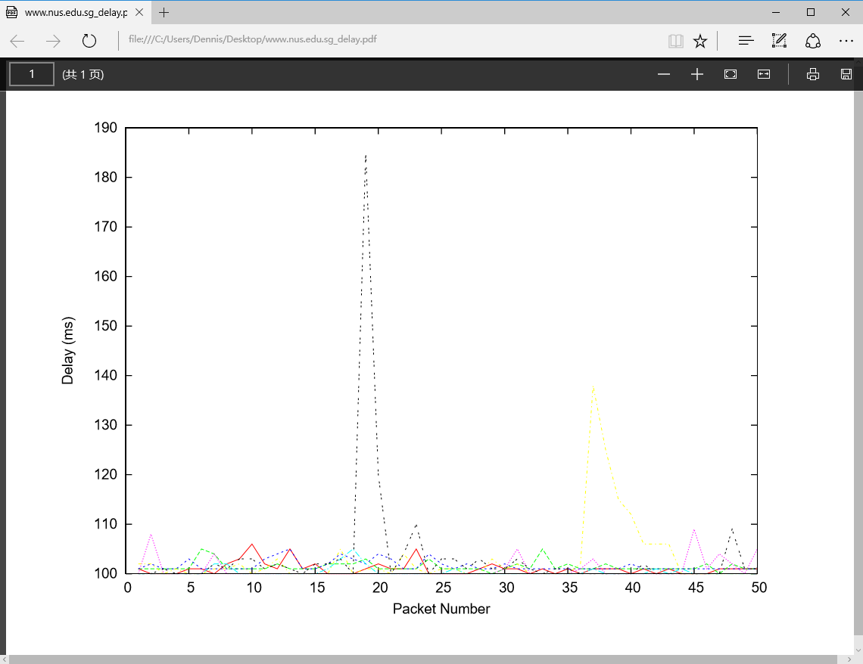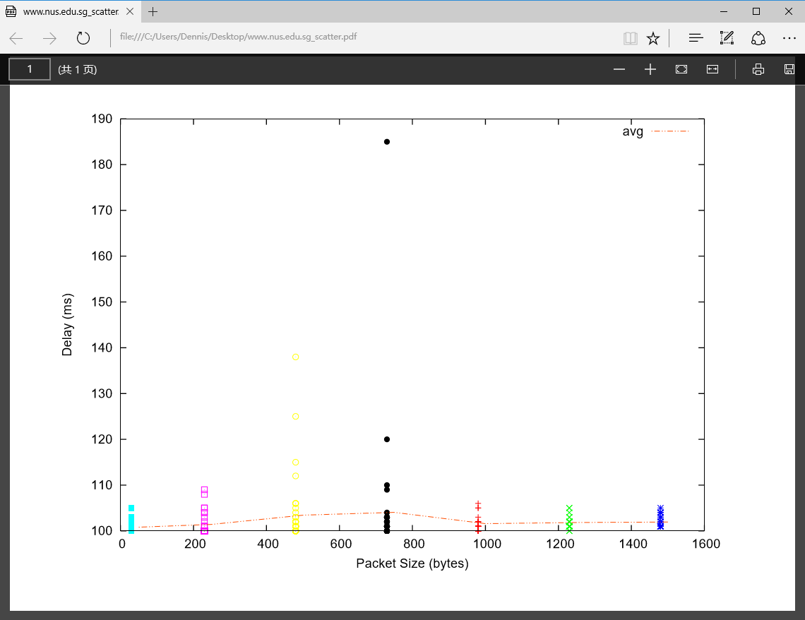

50 100.818 100.307

250 101.424 100.426

500 103.434 100.554

750 104.056 100.698

1000 101.597 100.858

1250 101.839 100.968

1500 101.942 101.055

www.tu-berlin.de

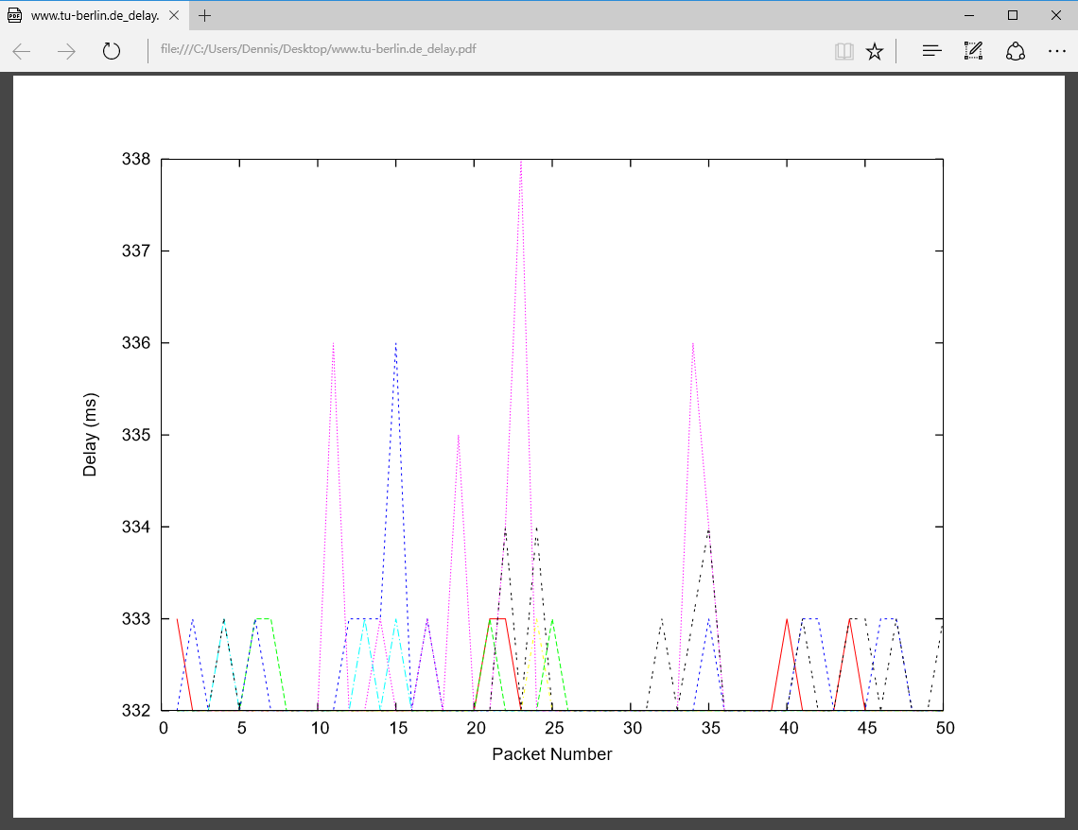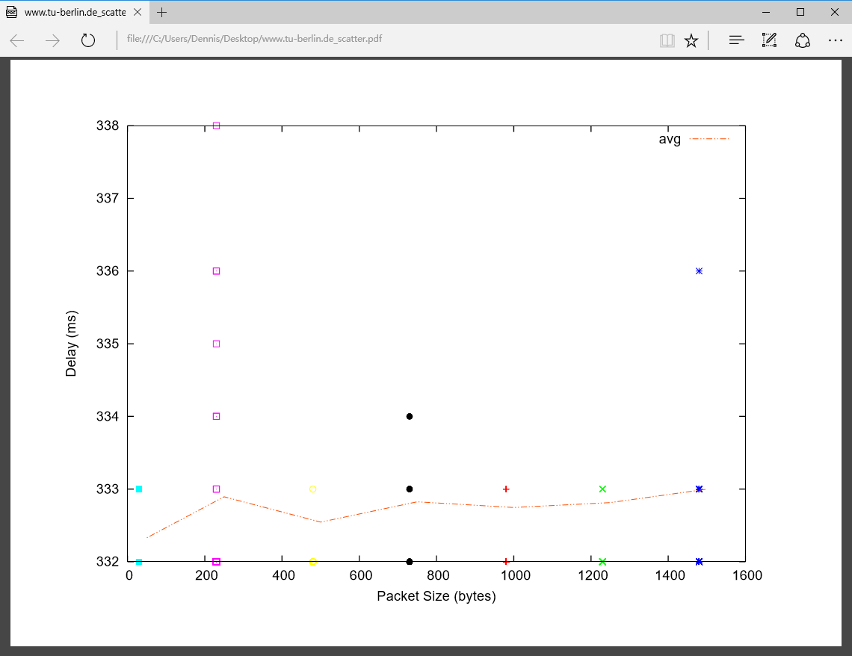

50 332.330 332.000

250 332.894 332.131

500 332.546 332.338

750 332.825 332.416

1000 332.746 332.495

1250 332.814 332.583

1500 332.999 332.685

www.uq.edu.au

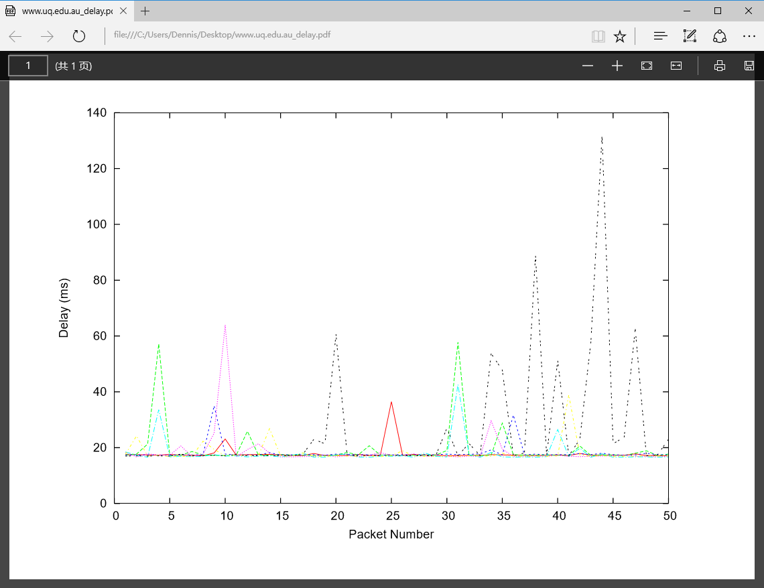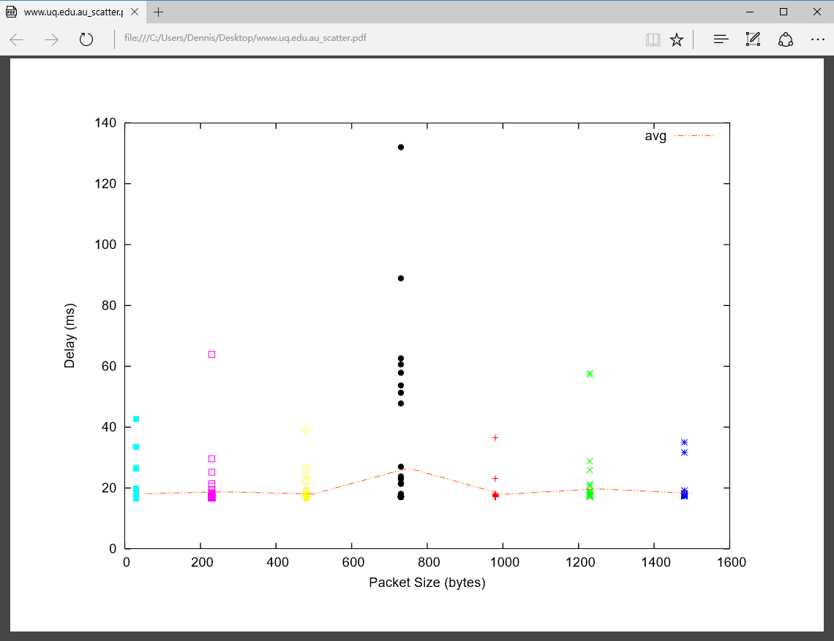

50 18.138 16.638

250 18.749 16.729

500 18.093 16.862

750 26.541 17.066

1000 17.929 17.159

1250 19.716 17.229

1500 18.222 17.338

1.

6332.91km 21.1ms 100.307/21.1=4.75

735.43km 2.45ms 16.638/2.45=6.79

16154.08km 53.84ms 332.000/53.84=6.16

First, the transition is a round trip, the packets should be sent to the destination and then back, so the sending distance is twice of the true distance. Second, the transition speed is lower than speed of light. Therefore, the y-values are no smaller than 2. Third, there are many delays compose in the transmission.

1. It is vary over time, since the packets switching is randomly. For Berlin the delay is depend on the size of the ping packets.

3.transmission delay and queueing delay depend on the packet size, propagation and processing delay are not.